
AARP Broker & Agent Social Media Guideline and Pre-Approved Content
January 2021
Introduction:
This is designed to guide and support you in promoting AARP® Real Estate Benefits from Realogy on social media platforms.
With this document, you will be able to increase the program’s awareness at a local level and associate yourself with AARP® Real Estate Benefits from Realogy in a compliant manner with the created and already approved social media content.
Document Goals:
- Provide pre-approved social media content and the only language that Brokers and Agents can distribute in their social networks if using the pre-approved content.
  - If you plan to deviate from the approved language or image – you must submit your content and an ad application to AffinityIdentityStandards@Cartus.com. It will take a minimum of 10 business days to go through the approval process.
- Provide guidelines as to how to advertise your association with the program on various social media platforms.
  - The program name must always be referenced as: AARP® Real Estate Benefits from Realogy
- Help Brokers and Agents increase program awareness at a local level.

Advertising your association on Websites:
- Only statement that can be used: I am a participating agent with AARP® Real Estate Benefits from Realogy
- Things to remember
  - Do not use the AARP logo
  - Can’t use #AARP Hashtag
  - Can’t state the word “AARP” only – use full program name
  - If advertising association with other rebate programs, they must be listed on separate lines

Sharing the AARP® Real Estate Benefits from Realogy Facebook posts – Steps:
https://www.facebook.com/search/top/?q=aarp%20real%20estate%20benefits%20from%20realogy&epa=SEARCH_BOX
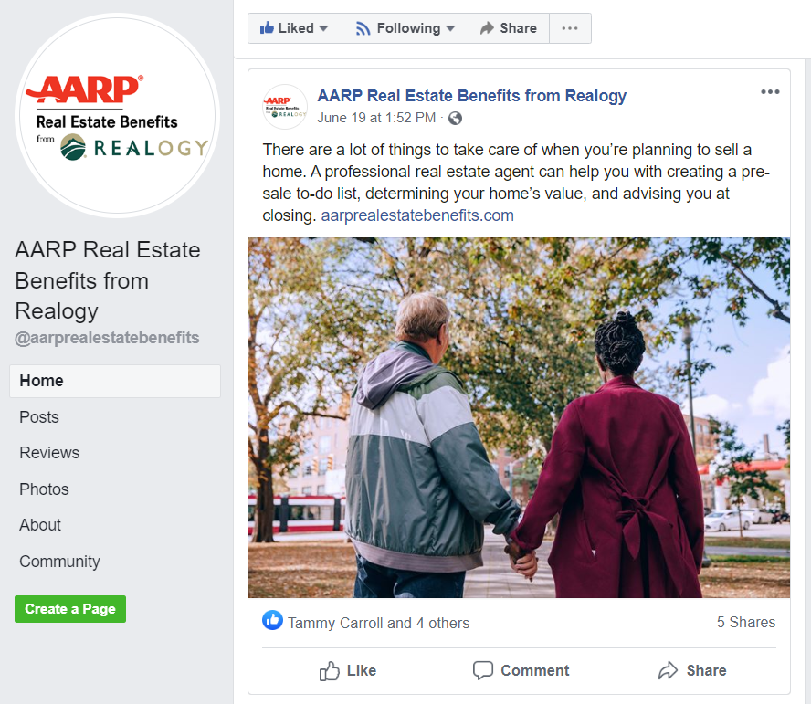 Click Share (NOT Share now)
Next – Time to add a message! Pick a messaging template option from below. Insert your email address or phone number into the message. By doing this, the member will contact you versus the program and then you submit the lead as an AGR.
Generic Post Templates to Share and Customize
Eleven images are available for the network brokers and “A” Team Agents can select. Images are housed in cartusnetworks.com under the AARP cobranding section in Affinity. Once the image has been decided, please select from the following messages to add to the post.
**Please make note regarding the generic posts!
- The ability to add your company logo to the social media post has not been approved at this time.
- Font- must appear in same weight and font throughout, no part may be bolded when the other is not
- Agent can use the word “team” if needed
- Contact information listed below in the individual posts is “example only” – user can customize the look and how much contact information is published
  - Agent/company website/url or Instagram name can also be included in the contact section.
- Use of hashtags
  - The hashtag #AARP or program is not allowed on ANY social media
  - All other hashtags are allowed

Options for Agents
Generic Messaging:
Agent Message Option 1: Have you heard of AARP® Real Estate Benefits from Realogy designed for AARP members? Contact me today to learn more. XXX-XXX-XXXX or at (email address)
Agent Message Option 2: Ready to buy a home? As a participating agent of AARP® Real Estate Benefits from Realogy, I am trained to work with AARP members. Contact me today to learn more. XXX-XXX-XXXX or at (email address)
Agent Message Option 3: Looking to downsize? On the fence? I am thrilled to be a participating agent of AARP® Real Estate Benefits from Realogy, and can help you throughout the home selling process. Give me a call at XXX-XXX-XXXX today or send a message to (email address) to learn more!
Agent Message Option 4: If you want to learn more about the real estate program designed for AARP members, I am participating agent with AARP® Real Estate Benefits from Realogy and can guide you through the process! Give me a call at XXX-XXX-XXXX or email me at (email address) to learn more.
Agent Message Option 5: Are you a member of AARP? As a participating real estate agent with AARP® Real Estate Benefits from Realogy. I am happy to assist you if you’re looking to buy or sell your home. Feel free to connect with me at (email address) or XXX-XXX-XXXX.
Agent Message Option 6: Do you need some real estate advice? Thinking about buying or selling? I can help as participating real estate agent with AARP® Real Estate Benefits from Realogy. Send me a quick Facebook message to connect with me.

Messaging that promotes the Cash Back Offer:
Agent Message Option 7: Looking to sell your home? Put my years of experience and local market knowledge to work for you! As a participating agent with AARP® Real Estate Benefits from Realogy, you will also get $300-$5,500 in benefits after closing. Send me a message to learn more!
Agent Message Option 8: I am proud to be a participating agent for AARP® Real Estate Benefits from Realogy, which offers $300-$5,500 in benefits after closing when you work with me to buy or sell your home! Contact me at XXX-XXX-XXX or send a message to (email address) to get started.
Agent Message Option 9: Have you heard of the new home buying and selling program designed for AARP members? Send me a message to learn how you can get $300-$5,500 in benefits when you buy or sell your home! I am proud to be a participating agent for AARP® Real Estate Benefits from Realogy.
Agent Message Option 10: Ask me about the amazing benefits you can receive as an AARP member when you buy or sell your home with me through AARP® Real Estate Benefits from Realogy! Call or text me at XXX-XXX-XXXX, or reach me by email at (email address)
Agent Message Option 11: Are you an AARP member? Contact me to find out how you can receive $300-$5,500 in benefits if you buy or sell a home with me through AARP® Real Estate Benefits from Realogy! XXX-XXX-XXXX or at (email address)
Agent Message Option 12: Let me help you buy or sell your home! I am uniquely trained and qualified to enroll you in AARP® Real Estate Benefits from Realogy, which gives you $300-$5,500 in benefits after closing. Send me a message to learn more!

Message Options for Real Estate Companies
Generic Messaging:
Message Option 1: Have you heard of AARP® Real Estate Benefits from Realogy designed for AARP members? Contact us today to learn more. XXX-XXX-XXXX or at (email address)
Message Option 2: Ready to buy a home? As a participating company of AARP® Real Estate Benefits from Realogy, we are trained to work with AARP members. Contact us today to learn more. XXX-XXX-XXXX or at (email address)
Message Option 3: Looking to downsize? On the fence? (Company Name) is thrilled to be a participating firm of AARP® Real Estate Benefits from Realogy, and can help you throughout the home selling process. Give us a call at XXX-XXX-XXXX today or send a message to (email address) to learn more!
Message Option 4: If you want to learn more about the real estate program designed for AARP members, (Company name) is a participating firm with AARP® Real Estate Benefits from Realogy and can guide you through the process! Give us a call at XXX-XXX-XXXX or email (email address) to learn more.
Message Option 5: Are you a member of AARP? As a participating real estate company with AARP® Real Estate, we are happy to assist you if you are looking to buy or sell your home. Feel free to connect with us at (email address) or XXX-XXX-XXXX.
Message Option 6: Do you need some real estate advice? Thinking about buying or selling? We can help as participating real estate company with AARP® Real Estate Benefits from Realogy. Send us a quick Facebook message to connect with us.

Messaging that promotes the Cash Back Offer:
Message Option 7: Looking to sell your home? Put our years of experience and local market knowledge to work for you! As an AARP® Real Estate Benefits from Realogy participating company, you will also get $300-$5,500 in benefits after closing. Send us a message to learn more!
Message Option 8: (Company name) is proud to be a participating firm for AARP® Real Estate Benefits from Realogy, which offers $300-$5,500 in benefits after closing when you work with us to buy or sell your home! Contact us at XXX-XXX-XXX or send a message to (email address) to get started.
Message Option 9: Have you heard of the new home buying and selling program designed for AARP members? Send us a message to learn how you can get $300-$5,500 in benefits when you buy or sell your home! (Company name) is proud to be a participating firm for AARP® Real Estate Benefits from Realogy.
Message Option 10: Ask us about the amazing benefits you can receive as an AARP member when you buy or sell your home with (Company Name) through AARP® Real Estate Benefits from Realogy. Call us at XXX-XXX-XXXX, or reach us by email at (email address)
Message Option 11: Are you an AARP member? Contact us to find out how you can receive $300-$5,500 in benefits if you buy or sell a home with (Company name) through AARP® Real Estate Benefits from Realogy! XXX-XXX-XXXX or at (email address)
Message Option 12: Let us help you buy or sell your home! (Company name) is uniquely trained and qualified to enroll you in AARP® Real Estate Benefits from Realogy, which gives you $300-$5,500 in benefits after closing. Send us a message to learn more!

Approved images are posted on cartusnetworks.com.

1/21

