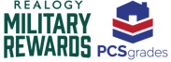

RMR Social Media Toolkit
Introduction:
Dear Brokers and Agents,
This Realogy Military Rewards Social Media Toolkit was created to guide and support you in promoting the RMR program through social media.
By using this social media toolkit, you will help increase the program’s awareness at a local level and associate yourself with the RMR program in a compliant manner.
Please review each section of the document to better understand our goals for sharing this strategy with you and the language to avoid using when sharing the social media content we have created.
If you need further clarification on any subject throughout the RMR Social Media Toolkit, please email the RMR Marketing Team, at AffinityIdentityStandards@cartus.com
Toolkit Goals:
- Provide the language to avoid when sharing RMR content

- Provide pre-approved social media content that Brokers and Agents can distribute to their Facebook social network

- Help Brokers and Agents increase program awareness at a local level

- To update this toolkit as needed to provide you with new content and posts to share – (i.e. we are excited to share our September Photoshoot Creative with you when we have it!)

RMR Social Media Channels:
In this section you will find RMR’s social media channels. Posts are shared weekly to continue to actively engage our followers with fresh content and promote the program.
*Please follow our Facebook and Twitter pages if you are not already!

RMR Facebook Channel: https://www.facebook.com/realogymilitaryrewards
RMR Twitter Channel: https://twitter.com/realogymrewards

PCSgrades:
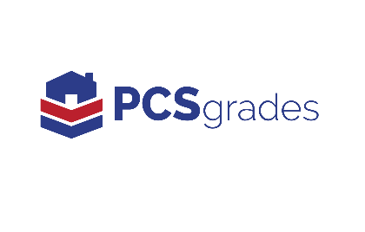
Realogy Military Rewards is proud to collaborate with PCSgrades in guiding military members through the home buying and selling process!
PCSgrades is a community of fellow military members, veterans, and military spouses helping each other with our biggest must-solve PCS and relocation needs by sharing our personal experiences and advice through trusted insights.

PCSgrades Social Media Channels:
PCSgrades Facebook: https://www.facebook.com/PCSgrades/
PCSgrades Twitter: https://twitter.com/PCSgrades
PCSgrades Instagram: https://www.instagram.com/pcsgrades/
PCSgrades Pinterest: https://www.pinterest.com/pcsgrades0038/
PCSgrades LinkedIn: https://www.linkedin.com/company/pcsgrades/
*Please follow if you are not already!

Co-Branding RMR | PCSgrades:
For guidance on how to treat the Realogy Military Rewards logo, seal, and PCSgrades logos when used together, please do not create your own social media posts using both logos. Only share pre-approved image content provided. (Discussed below)
We also encourage you to #hashtag or share PCSgrades social media posts from their pages listed above.

#hashtags that you can add to your posts:

#PCSgrades, #PCS, #pcsmove, #PCSnews, #MilitaryFamily

To tag PCSgrades directly into your social media posts:

- On Facebook: tag “@PCSgrades”
- On Twitter: tag “@PCSgrades”
- On Instagram: tag “@pcsgrades”

Please reference the RMR style guide on CartusNetworks.com for more on co-branding RMR | PCSgrades guidelines for print materials.

How to post in your personal Facebook channel:
- Share posts that are on the Realogy Military Rewards Facebook directly to your network by hitting the share button on a post (Most important! Please reference the audience to contact you directly and include your contact information): https://www.facebook.com/realogymilitaryrewards/
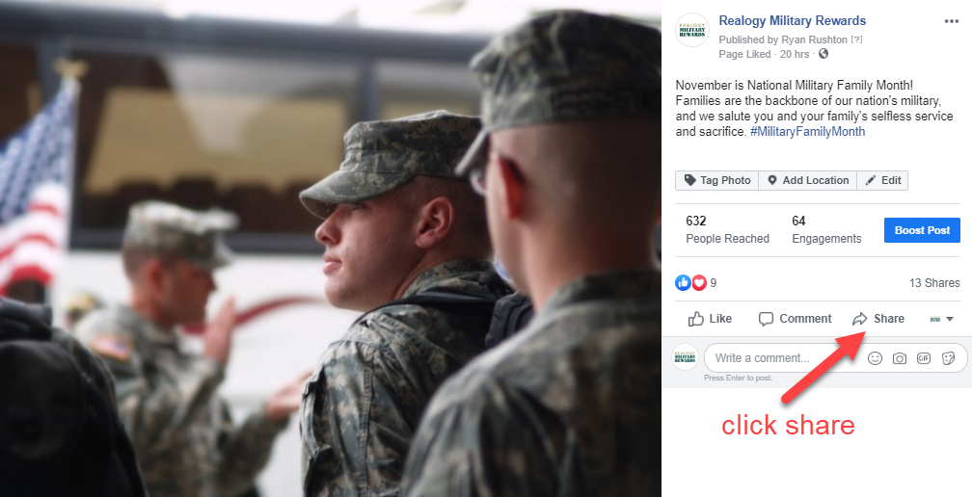

- Create your own! See the attached document for a variety of approved image options. Generic post templates have been created below for your use. Insert your email address or phone number into the templates so you can receive AGR credit. Images to use in posts are uploaded in the RMR section of cartusnetworks.com.

Use Our Pre-Approved Agent Messages to Share to Your Social Media Audiences:

Generic Templates to Share and Customize:
I am very proud and excited to announce that I am a Realogy Military Rewards real estate agent! Contact me for more information about this exciting program. (Insert Your Email Address XXX@ or Phone #: XXX-XXX-XXXX)
Proudly serving the military! Ready to buy or sell your home? Contact me for more information on the new Realogy Military Rewards program. (Insert Your Email Address XXX@ or Phone #: XXX-XXX-XXXX)
Wherever life moves you, I am here to help as a Realogy Military Rewards agent! Feel free to contact me to learn more about the program! (Insert Your Email Address XXX@ or Phone #: XXX-XXX-XXXX)
Ask me about the great benefits you can receive in the Realogy Military Rewards program when you buy or sell your home with me! Call or text me at XXX-XXX-XXXX, or reach me by email at (email address).
Ready to buy a home? As a participating agent of the Realogy Military Rewards program, I am trained to help military members, veterans, and their extended families throughout the home buying process. Contact me today to learn more. XXX-XXX-XXXX or at (email address).
If you want to learn more about this real estate program that was designed for military members, veterans, and their extended families, I am a participating agent and can guide you through the process! Give me a call at XXX-XXX-XXXX or email me at (email address) to learn more.
I am honored to help military families and veterans buy and sell their homes. Thank you for your service! Feel free to connect with me at (email address) or XXX-XXX-XXXX.
Looking to find your next home? I have the experience to help military families and veterans find their perfect home as a participating agent of the Realogy Military Rewards program. Contact me at XXX-XXX-XXXX or (email address) to get started.

Templates Promoting $350 to $7,500* Cash Back Offer:
I am very proud and excited to announce that I am a Realogy Military Rewards real estate agent! I am here to serve Veterans, military personnel, and their extended families find a home. Ask me how you can get $350 to $7,500* in cash back! (Insert Your Email Address XXX@ or Phone #: XXX-XXX-XXXX)

Attention military families! I am pleased to introduce the Realogy Military Rewards program, which helps Veterans, military personnel, and their extended families find a home. Contact me to learn how you can get $350 to $7,500* in cash back! (Insert Your Email Address XXX@ or Phone #: XXX-XXX-XXXX)

It is my turn to serve you! Realogy Military Rewards is a new home buying and selling program that will offer $350 to $7,500* in cash back to those who served our country and their extended families. Contact me to find out more! (Insert Your Email Address XXX@ or Phone #: XXX-XXX-XXXX)
Exciting news! Introducing the new home buying and selling program Realogy Military Rewards, which offers $350 to $7,500* in rewards to those who served our country. Contact me to learn more! (Insert Your Email Address XXX@ or Phone #: XXX-XXX-XXXX)
Are you a military service member or veteran? Contact me to find out how you can receive 350-$7,500 in benefits if you buy or sell a home with me through the Realogy Military Rewards program! XXX-XXX-XXXX or at (email address).
I am very proud and excited to announce that I am a Realogy Military Rewards real estate agent! I am here to serve Veterans, military personnel, and their extended families find a home. Ask me how you can get $350 to $7,500* in rewards! (Insert Your Email Address XXX@ or Phone #: XXX-XXX-XXXX)
Attention military families! I am pleased to introduce the Realogy Military Rewards program, which helps Veterans, military personnel, and their extended families find a home. Contact me to learn how you can get $350 to $7,500* in rewards! (Insert Your Email Address XXX@ or Phone #: XXX-XXX-XXXX)
It is my turn to serve you! Realogy Military Rewards is a new home buying and selling program that will offer $350 to $7,500* in rewards to those who served our country and their extended families. Contact me to find out more! (Insert Your Email Address XXX@ or Phone #: XXX-XXX-XXXX)
Exciting news! Introducing the new home buying and selling program Realogy Military Rewards, which offers $350 to $7,500* in cash back to those who served our country. Contact me to learn more! (Insert Your Email Address XXX@ or Phone #: XXX-XXX-XXXX)

Templates for Gift Card States (Tennessee and Kansas):
I am very proud and excited to announce that I am a Realogy Military Rewards real estate agent! I am here to serve Veterans, military personnel, and their extended families find a home. Ask me how you can get $350 to $7,500* in a loyalty gift card! (Insert Your Email Address XXX@ or Phone #: XXX-XXX-XXXX)
Attention military families! I am pleased to introduce the Realogy Military Rewards program, which helps Veterans, military personnel, and their extended families find a home. Contact me to learn how you can get $350 to $7,500* in a loyalty gift card! (Insert Your Email Address XXX@ or Phone #: XXX-XXX-XXXX)
It is my turn to serve you! Realogy Military Rewards is a new home buying and selling program that will offer $350 to $7,500* in a loyalty gift card to those who served our country and their extended families. Contact me to find out more! (Insert Your Email Address XXX@ or Phone #: XXX-XXX-XXXX)
Exciting news! Introducing the new home buying and selling program Realogy Military Rewards, which offers $350 to $7,500* in a gift card to those who served our country. Contact me to learn more! (Insert Your Email Address XXX@ or Phone #: XXX-XXX-XXXX)

